GUJARAT TECHNOLOGICAL UNIVERSITY
AHMEDABAD
Affiliated to
 | 
SAL College of Engineering

A Report on
React Native Order & Sales Management App
Under the Subject of
Design Engineering II B (3150001)
B. E. III, Semester-VI
Computer Engineering

Submitted By:

Sr. No | Enrollment No | Student Name
1 | 231130107046 | PATEL ARYAN SURESHKUMAR
2 | 231130107050 | DIVY NILESHKUMAR PATEL
3 | 231130107036 | PADMRAJSINH ARJUNSINH BARAD
4 | 231130107027 | SMIT AVINASH KUHIKAR
5 | 231130107068 | UMERIMRAN KHAN

Prof. Janki Patel
Internal Guide

Prof. Vijaysinh Jadeja
Head of the Department

Academic Year
(2026-2027)

GUJARAT TECHNOLOGICAL UNIVERSITY
AHMEDABAD
Affiliated to
 | 
SAL College of Engineering

CERTIFICATE

This is to certify that the project report on React Native Order & Sales Management App
Submitted by:

Sr. No | Enrollment No |  | Name
1 |  | 231130107046 |  | PATEL ARYAN SURESHKUMAR
2 |  | 231130107050 |  | DIVY NILESHKUMAR PATEL
3 |  | 231130107036 |  | PADMRAJSINH ARJUNSINH BARAD
4 |  | 231130107027 |  | SMIT AVINASH KUHIKAR
5 |  | 231130107068 |  | UMERIMRAN KHAN

As fulfillment of the requirement for the award B.E. in Computer Engineering Semester 6th at Sal College of Engineering is the record of work that has been successfully and satisfactorily completed under supervision and guidance during the academic year 2026-27.

Prof. Janki Patel | Prof. Vijaysinh Jadeja
Internal Guide  CE/IT Department | Head of the Department  CE/IT Department

ABSTRACT

React Native Order & Sales Management App
(Transforming Field Sales Through Mobile Technology)

This project presents a React Native mobile application designed to modernize and simplify the order lifecycle for small-to-medium retailers and wholesalers who currently rely on desktop-based accounting software like Tally ERP. The application addresses the gap of traditional desktop-centric systems by providing a mobile-first, cloud-ready system for comprehensive sales order management. It enables field sales representatives to create orders instantly at customer locations, managers to approve orders with embedded customer ledger visibility for informed credit decisions, and warehouse staff to efficiently process and dispatch orders. The system features eight core modules: Dashboard, New Order, Pending Approvals, Process Orders, My Orders, Products, Customers, and Analytics. The current implementation features a complete frontend with deterministic mock data, demonstrating full functionality without a live backend, with plans for future integration.

LIST OF FIGURES

Figure No | Figure Description | Page No
2.1 | AEIOU Canvas | 11
2.2 | Empathy Canvas | 13
2.3 | Mind map | 16
3.1 | Ideation Canvas | 18
4.1 | Product Development Canvas | 19
5.1 | Learning Need Matrix | 24
6.1 | Flowchart/Prototype | 26

TABLE OF CONTENT
Chapter No | Chapter Title |  | Page No
Chapter 1 | Introduction |  | 7
 | 1.1 | Design Thinking | 7
 | 1.2 | Importance of design thinking | 7
 | 1.3 | Learning tools and assignments | 8
 | 1.4 | The idea to make a project | 8
Chapter 2 | Empathy Mapping |  | 9
 | 2.1 | Why this domain | 9
 | 2.2 | Observation | 9
 | 2.3 | AEIOU Canvas | 11
 | 2.4 | Empathy Canvas | 13
 | 2.5 | Mind mapping | 16
 | 2.6 | Conclusion of empathy mapping | 16
Chapter 3 | Ideation Canvas |  | 17
 | 3.1 | Ideation Canvas(people) | 17
 | 3.2 | Ideation Canvas (Activity) | 17
 | 3.3 | Ideation Canvas (Situation & location) | 17
 | 3.4 | Ideation Canvas(Props) | 17
 | 3.5 | Ideation Canvas(Image) | 18
Chapter 4 | Product Development Canvas |  | 19
 | 4.1 | Final Problem statement | 19
 | 4.2 | PDC(purpose) | 19
 | 4.3 | PDC (people) | 20
 | 4.4 | PDC (Product Experience) | 20
 | 4.5 | PDC (Product Functions) | 20
 | 4.6 | PDC (Product Features) | 20
 | 4.7 | PDC(Components) | 21
 | 4.8 | PDC (Customer Revalidation) | 21
 | 4.9 | PDC (Reject, Redesign, Retain) | 21
 | 4.10 | PDC(Explanation) | 22
 | 4.11 | PDC(Feedback) | 22
 | 4.12 | PDC(Revalidation) | 23
Chapter 5 | Learning Need Matrix |  | 24
 | 5.1 | Theory / Methods | 24
 | 5.2 | Applicable Standard Principles | 24
 | 5.3 | Software/ Tools /Skills | 25
 | 5.4 | Components /Strength | 25
Chapter 6 | Prototype |  | 26
 | 6.1 | Algorithm/Flowchart | 26
 | 6.2 | Modal/Prototyping | 26
Chapter 7 | Enhancements |  | 28
 | 7.1 | Future Enhancements | 28
Chapter 8 | Conclusion |  | 29
 | 8.1 | Conclusion | 29
 | Appendix - I Prior Art Search
 | Appendix - II Rough Proofs
 | Appendix - IIIMonthly Assessment Report

Chapter 1
Introduction
- Design Thinking
Design Thinking is a human-centered problem-solving methodology that focuses on understanding user needs, redefining problems, and developing innovative solutions. In the context of field sales and distribution management, design thinking emphasizes empathy toward sales representatives who visit 10-15 retail shops daily but cannot enter orders on-site, distribution managers who must manually verify customer creditworthiness before approving orders, and warehouse staff who rely on paper-based dispatch tracking

Rather than simply digitizing existing Tally ERP workflows, this approach allowed deep understanding of user pain points such as duplicate data entry, approval bottlenecks, and lack of real-time visibility. Through iterative stages of empathizing, defining, ideating, prototyping, and testing, the Order Management App ensures a practical and mobile-first platform that addresses genuine field operation challenges

- Importance of design thinking
Design thinking plays a crucial role in addressing real-world enterprise challenges like inefficient field operations, approval bottlenecks, and communication gaps between sales teams and management. It helps engineers and designers look beyond technical solutions to focus on human experience. In the Order Management App, design thinking ensures that the application is built not just as a mobile interface, but as a comprehensive workflow solution that embeds credit risk management, eliminates duplicate data entry, and provides role-based interfaces optimized for specific user tasks.

Empathy mapping helped identify user frustrations such as 2-3 hours wasted daily on manual order transcription and 5-15 minutes per order spent checking Tally ledgers. Ideation and prototyping stages refined features like embedded customer ledger visibility during approval workflows and deterministic mock data for demonstrations.

- Learning tools and assignments
During the development of the Order Management App, various design and analytical tools were utilized to apply design thinking principles effectively:
- AEIOU Canvas: Used during field research to systematically observe Activities, Environments, Interactions, Objects, and Users.
- Empathy Canvas: Helped map what users say, think, do, and feel during order management.
- Mind Mapping: Organized the complex ecosystem into domains: Product, Customer, Order Workflow, Analytics, and Architecture.
- Ideation Canvas: Structured brainstorming to generate feature ideas based on People, Activities, Situations, and Props.
- Product Development Canvas: Translated ideas into specifications by defining Purpose, People, Experience, Functions, Features, Components, and Validation Criteria.
- Learning Need Matrix: Identified knowledge gaps (e.g., REST API design, state management) and required skills (e.g., React Native, TypeScript).
- Technical Tools: React Native, Expo, TypeScript, AsyncStorage, Victory Native for charts, and Git/GitHub.

- The idea to make a project
The idea originated from observing recurring inefficiencies, sales representatives maintaining physical notebooks during shop visits, spending 2-3 hours daily transcribing orders into Tally ERP, managers requiring 5-15 minutes per order to manually verify customer credit status, and warehouse staff working with printed order lists without digital dispatch tracking.​The system enables field sales representatives to create orders instantly at customer locations, distribution managers to approve orders with embedded customer ledger visibility, and warehouse staff to digitally mark orders as dispatched with timestamps. Real-time order status visibility and role-based interfaces make the process transparent and efficient across all stakeholders.​​By combining user empathy with modern mobile technologies, the App eliminates duplicate data entry, reduces order creation time to under 60 seconds, and streamlines approval workflows to under 2 minutes—turning everyday business inefficiencies into opportunities for digital transformation.
Chapter 2
Empathy Mapping
2.1Why This Domain
The retail and wholesale distribution sector in India heavily relies on desktop-based accounting software like Tally ERP. While powerful for accounting, it is not optimized for field operations.
This domain was selected to solve several critical problems:
- Inefficient Field Operations: Sales reps waste 2-3 hours daily on duplicate data entry (notebook to Tally).
- Approval Bottlenecks: Managers spend 5-15 minutes per order manually checking customer ledgers in Tally before approving.
- Limited Visibility: Sales reps have no real-time status updates on their submitted orders (pending, approved, dispatched).
- Paper-Based Dispatch: Warehouse operations rely on printed lists, leading to no digital record of dispatch times or fulfilment.
- Missing Business Intelligence: Decision-makers lack actionable, real-time analytics on sales trends and team performance.
The high smartphone penetration (nearly 100%) among sales reps creates an ideal opportunity for a mobile-first solution.

2.2Observation
Systematic observation sessions were conducted with three field sales representatives, two distribution managers, and three warehouse dispatch staff across two distribution businesses. ​

Field Sales Representative Observation: Representatives begin at 9:00 AM collecting product samples and paper catalogs. Shop visits last 10-20 minutes recording orders in physical notebooks with product codes and quantities. Representatives expressed frustration about remembering product categories, worrying about transcription errors, having no way to check customer credit status during visits, and inability to provide immediate order confirmation. Return to office around 1:30 PM and spend 2-3 hours entering orders into Tally with error rates of 1-2 per 20 orders.
​Distribution Manager Observation: Managers review pending orders twice daily (11:00 AM-12:00 PM and 4:00 PM-5:00 PM). Workflow involves opening Tally, reviewing each order, then switching to customer ledger reports to check credit/debit balances. Decision factors include outstanding balance, order value over ₹50,000, customer payment history, and strategic business relationships. Approval decisions take 2-5 minutes for straightforward cases but extend to 15-20 minutes for complex situations requiring phone calls. Managers expressed frustration about context-switching between order details and ledger reports, lack of mobile access, and difficulty tracking which orders have been reviewed.
​
Warehouse Dispatch Staff Observation: Morning begins with printing approved orders from Tally. Staff manually check off items as packed into boxes. Observed challenges include paper management (printouts get dirty or torn), handwriting issues, no timestamps for dispatch events, unclear priorities, and exception handling when items are out of stock. Dispatch manager expressed desire for digital checklists with timestamps and automatic notifications to sales representatives.

2.3AEIOU Canvas
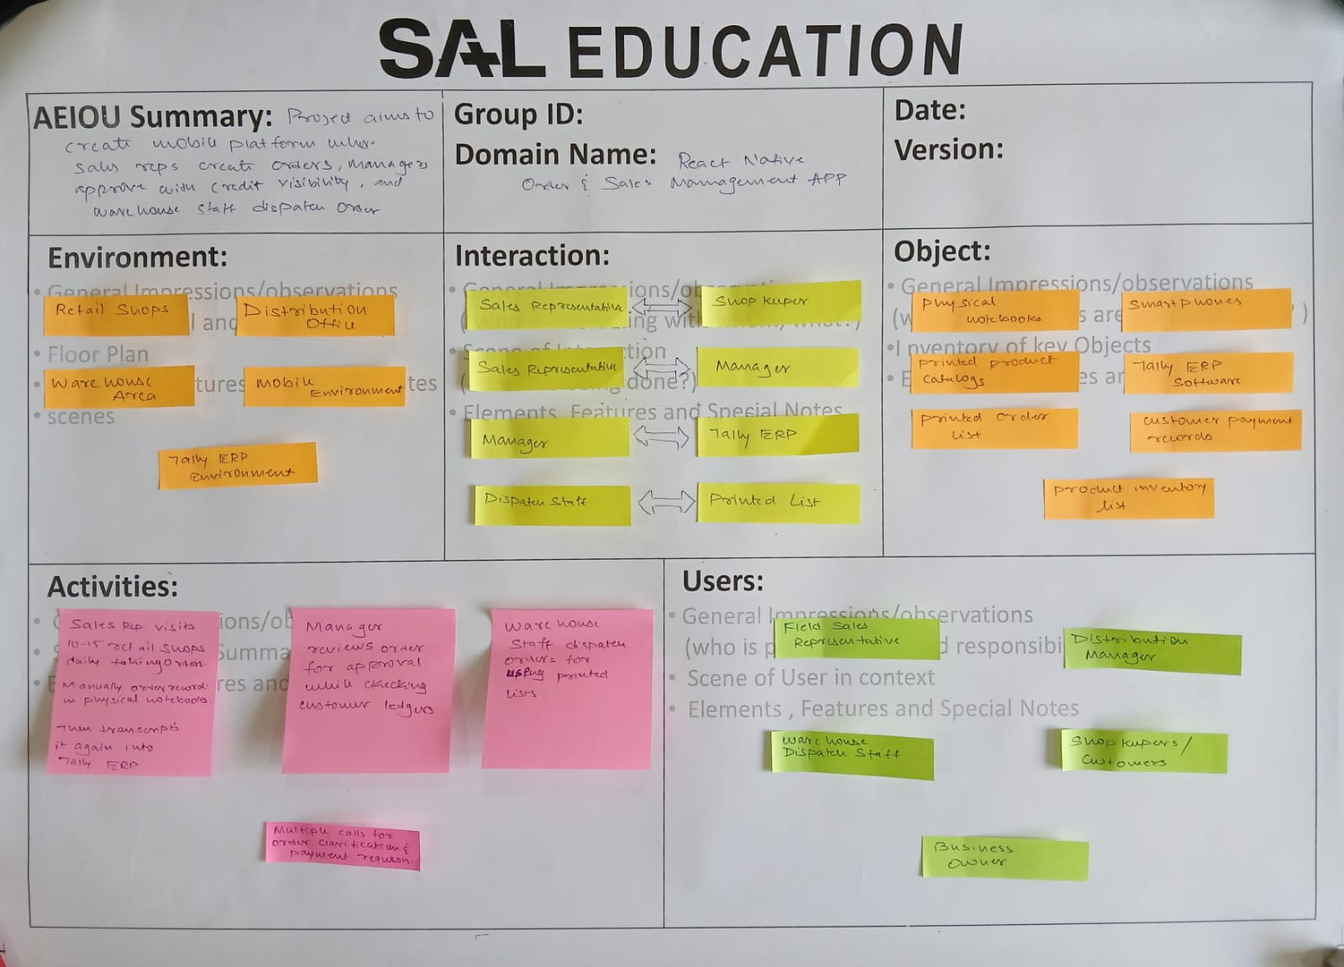
Environment: Retail shops, distribution office, warehouse area, mobile/field environment, desktop Tally ERP environment, noisy crowded shop interiors, variable network connectivity.
​
Activities: Sales representatives visit 10-15 retail shops daily taking orders. Manual order recording in physical notebooks during customer visits. Evening transcription into Tally ERP consuming 2-3 hours daily. Manager reviews orders for approval while checking customer ledgers. Warehouse staff dispatch orders using printed lists. Multiple phone calls for order clarifications and payment requests.
​
Interactions: Sales Rep interacts with Shopkeeper (order taking), Sales Rep communicates with Manager (order submission, approval status), Manager uses Tally ERP (ledger checking), Manager reviews Customer Ledgers (credit verification), Dispatch Staff works with Printed Lists (fulfilment), Sales Rep calls Customers (payment follow-up), Manager approves/rejects Sales Rep orders.
​
Objects: Physical notebooks, smartphones (underutilized for business), printed product catalogs, Tally ERP software, printed order lists, pens and calculators, order vouchers, customer payment records, product inventory lists.
​
Users: Field Sales Representatives (25-40 years old, medium tech comfort, create orders, visit customers, need speed and simplicity), Distribution Managers (35-55 years old, high tech comfort, approve/reject orders, need credit risk visibility and business intelligence), Warehouse Dispatch Staff (25-50 years old, basic tech comfort, process approved orders, need simple checklists and confirmation workflows), Shopkeepers/Customers (indirect users, receive orders and deliveries).
​

2.4Empathy Canvas
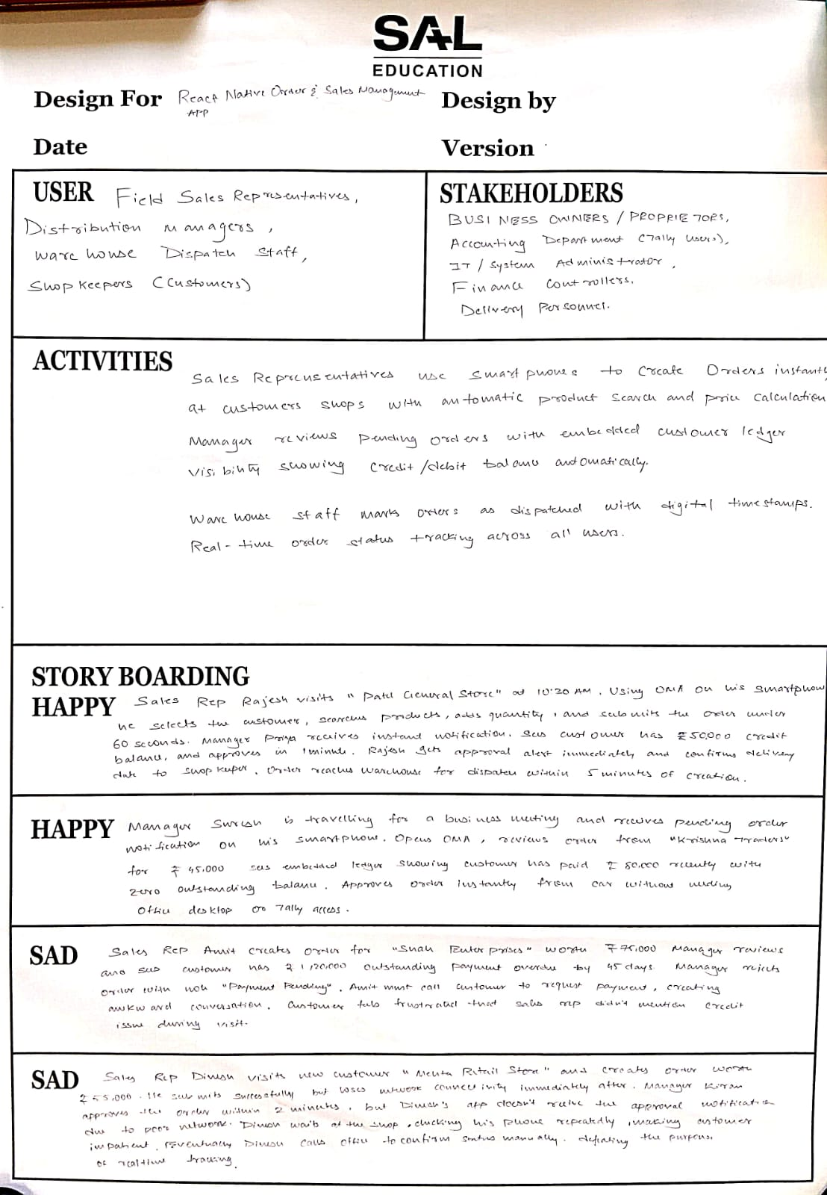
Users: Field Sales Representatives, Distribution Managers, Warehouse Dispatch Staff, Shopkeepers (Customers).
​
Stakeholders: Business Owners/Proprietors, Accounting Department (Tally users), IT/Systems Administrator, Finance Controllers, Delivery Personnel.
​
Activities: Sales representatives use smartphones to create orders instantly at customer shops with automatic product search and price calculation.
Manager reviews pending orders with embedded customer ledger visibility showing credit/debit balance automatically.
Warehouse staff marks orders as dispatched with digital timestamps. Real-time order status tracking across all users.
​
Story Boarding - Happy Scenario 1: Sales Rep Rajesh visits "Patel General Store" at 10:30 AM. Using OMA on his smartphone, he selects the customer, searches products ("Sunflower Oil"), adds quantities, and submits the order in under 60 seconds. Manager Priya receives instant notification, sees customer has ₹5,000 credit balance, and approves in 1 minute. Rajesh gets approval alert immediately and confirms delivery date to shopkeeper. Order reaches warehouse for dispatch within 5 minutes of creation.
​
Happy Scenario 2: Manager Suresh is traveling for a business meeting and receives pending order notification on his smartphone. Opens OMA, reviews order from "Krishna Traders" for ₹45,000, sees embedded ledger showing customer has paid ₹80,000 recently with zero outstanding balance. Approves order instantly from car without needing office desktop or Tally access.
​
Sad Scenario 1: Sales Rep Amit creates order for "Shah Enterprises" worth ₹75,000. Manager reviews and sees customer has ₹1,20,000 outstanding payment overdue by 45 days. Manager rejects order with note "Payment pending". Amit must call customer to request payment, creating awkward conversation. Customer feels frustrated that sales rep didn't mention credit issue during visit.
​

Sad Scenario 2: Sales Rep Dinesh creates order for "Mehta Retail Store" worth ₹55,000. He submits successfully but loses network connectivity immediately after. Manager Kiran approves the order within 2 minutes, but Dinesh's app doesn't receive the approval notification due to poor network. Dinesh waits at the shop for 20 minutes checking his phone repeatedly, making customer impatient. Eventually Dinesh calls office to confirm status manually, defeating the purpose of real-time tracking. Customer complains about the wait and questions reliability of the "new system."

2.5Mind Map
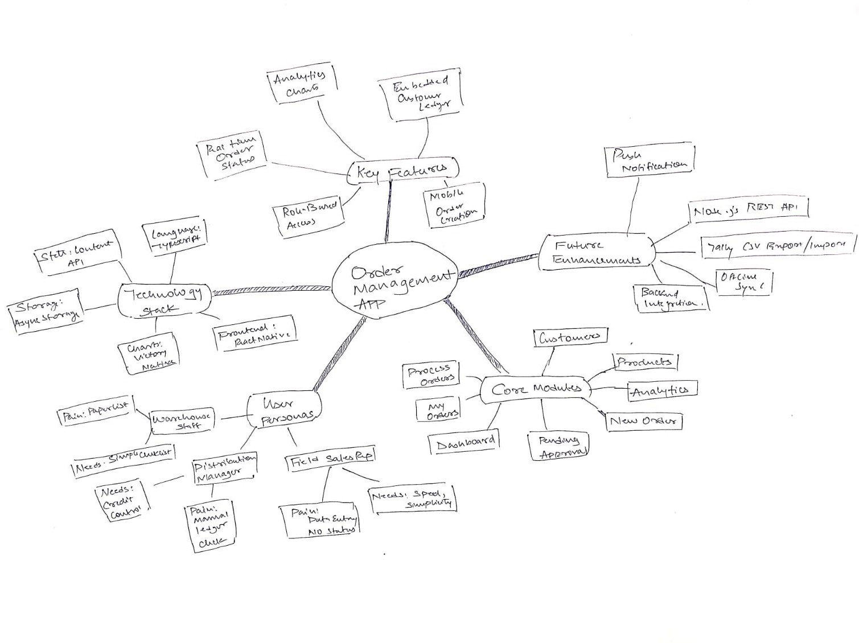

2.6Conclusion of Empathy Mapping
The empathy mapping process was critical. It confirmed that the core problem is not just a lack of digitization, but a complete disconnect between field operations and back-office accounting.
- Sales representatives are stuck in a loop of manual entry and information blindness.
- Managers are trapped in a bottleneck of manual verification, hindering business agility.
- Warehouse staff operate on an outdated paper-based system.
The key insight is that any solution must deliver real-time data at the point of action: credit status for the manager during approval, and order status for the sales rep on the field. Simply creating a mobile data entry form is not enough; the value is in the integration and flow of information between user roles.

Chapter 3
Ideation Canvas
3.1People
- Field Sales Representatives (Primary Users)
- Distribution Managers (Approval/Admin Users)
- Warehouse Dispatch Staff (Fulfilment Users)
- Shopkeepers / Retailers (Indirect Users / Customers)
- Business Owner / Accountant (Stakeholder)

3.2Activity
- Creating a new order on a mobile phone in < 60 seconds.
- Searching a digital product catalog.
- Viewing customer's credit balance instantly.
- Approving/Rejecting an order with one tap.
- Viewing a digital list of orders to be packed.
- Marking an order as "Dispatched."
- Tracking order status in real-time (Pending -> Approved -> Dispatched).

3.3Situation and location
- Sales Rep: On-site at a customer's shop (noisy, busy), in a car between visits, at home in the evening.
- Manager: At the office desk, at home, or traveling (needs mobile access).
- Dispatch Staff: In the warehouse, at the loading dock.

3.4Props
- Role-based login (Rep, Manager).
- Module: New Order: Digital form with customer search, product search, and quantity input.
- Module: Pending Approvals: A list of orders for managers.
- Module: Process Orders: A digital "To-Do" list for dispatch staff.
- Module: My Orders: A status tracker for sales reps.
- Module: Analytics: Mobile dashboard with charts (e.g., revenue, top customers).
3.5Image
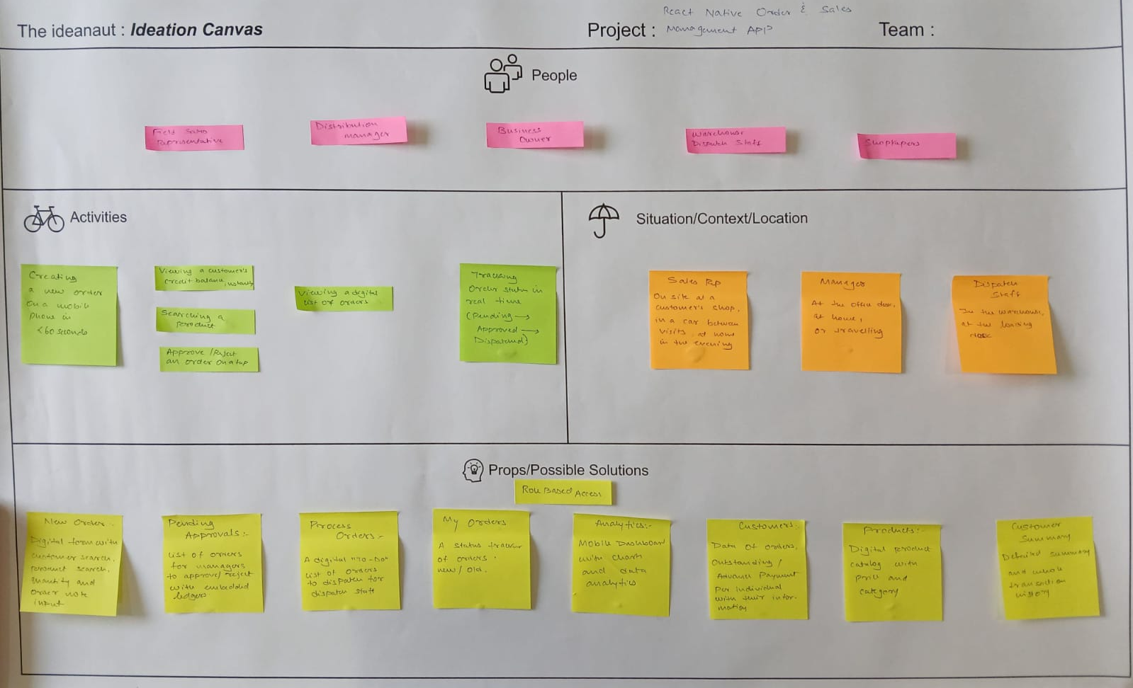
​

Chapter 4
Product Development Canvas
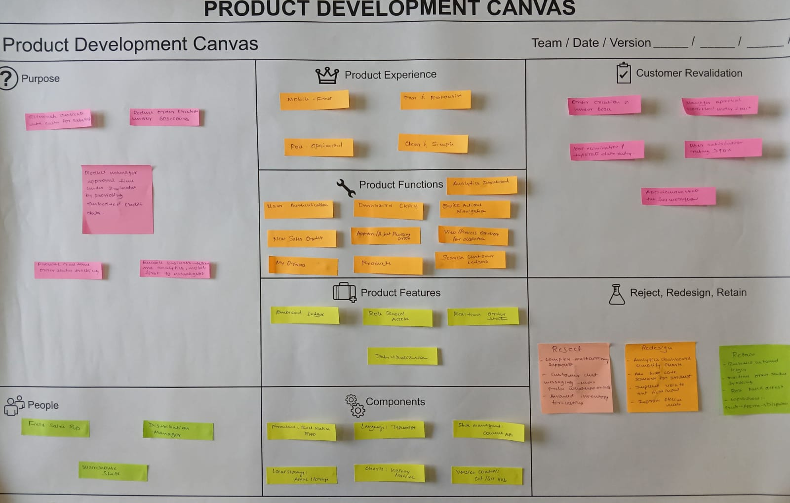
4.1Final Problem Statement
Field sales representatives waste 2-3 hours daily on manual, duplicate order entry (notebook-to-Tally), which introduces errors. Distribution managers are bottlenecked, spending 5-15 minutes per order manually cross-referencing Tally ledgers for credit status. This combined inefficiency delays order fulfilment, strains customer relations, and provides zero real-time business intelligence.

​
4.2Purpose
- Eliminate 100% of duplicate data entry for sales reps.
- Reduce order creation time to under 60 seconds.
- Reduce manager approval time to under 2 minutes by providing embedded credit data.
- Provide real-time order status tracking for all stakeholders (Pending, Approved, Dispatched).
- Enable mobile-first business intelligence and analytics for managers.​
4.3People
- Field Sales Rep: Needs speed, simplicity, and real-time status updates.
- Distribution Manager: Needs credit risk control, approval workflow, and high-level analytics.
- Warehouse Dispatch Staff: Needs a simple, clear checklist of approved orders to pack.
​
4.4Product Experience
- Mobile-First: Designed for on-the-go use, not as a desktop port.
- Fast & Responsive: UI must be quick, with instant search and calculations.
- Role-Optimized: The UI for a Sales Rep is different from a Manager's. A rep sees "New Order," a manager sees "Approve Orders."
- Clear & Simple: High-contrast, legible text. Obvious buttons. No complex forms.

4.5 Product Functions
- User Authentication (Sign In)
- Dashboard (KPIs)
- Quick Actions Navigation
- Create New Sales Order
- Approve/Reject Pending Orders
- View/Process Orders for Dispatch
- List/Search "My Orders"
- List/Search Products
- List/Search Customers (with Ledger)
- View Analytics Dashboard

4.6Product Features
- Embedded Ledger: Customer's credit/debit balance is shown on the approval screen.
- Deterministic Mock Data: A hidden trigger populates the app with consistent, realistic data for demos.
- Role-Based Access Control: UI and data access change based on user role (Manager/User).
- Real-time Order Status Tags: (Pending, Review, Approved, Dispatched).
- Data Visualization: Charts for Total Revenue, Avg. Order Value, etc.
​
4.7Components
- Frontend: React Native (with Expo)
- Language: TypeScript
- State Management: React Context API
- Local Storage: AsyncStorage (for user session, mock data)
- Charts: Victory Native
- Version Control: Git / GitHub

​
4.8Customer Revalidation
- Order creation time is under 60 seconds.
- Manager approval workflow is under 2 minutes.
- 100% elimination of duplicate data entry.
- User satisfaction rating > 90% in testing sessions.
- App successfully demonstrates the full workflow (create -> approve -> dispatch) using mock data mode.

4.9Reject, Redesign, Retain
Retain:
- Embedded customer ledger in approval workflow
- Real-time order status tracking across user roles
- Role-based dashboards with relevant stats per user type
- Core 3-step workflow: Create → Approve → Dispatch

Redesign:
- Analytics dashboard: simplify charts; add date-range filters
- Product search: add barcode scanning for faster lookup
- Order notes: implement voice-to-text for field input
- Offline mode: improve local storage for poor connectivity

Reject:
- Complex multi-currency support — out of scope
- Customer chat messaging — users prefer phone calls
- Advanced inventory forecasting — beyond current maturity

​4.10Explanation
The Product Development Canvas (PDC) was used to translate the abstract ideas from the ideation phase into a concrete, structured project plan. It forced us to define the exact user personas (People), the core value proposition (Purpose), and the specific, tangible functionalities (Functions & Features) required to deliver that value. This canvas ensures that every feature built directly maps back to a user need and a project goal, preventing scope creep and keeping the focus on solving the primary problems of manual data entry and credit-check bottlenecks.

4.11Feedback
- Positive (Sales Reps):
  - "This is amazing. It's so much faster than writing in my notebook."
  - "I love that I can finally see my order status. I always have to call the office for this."
  - "The customer search and product list are very easy to use."
- Positive (Managers):
  - "The embedded ledger on the approval screen is the single most important feature. This saves me 90% of my time."
  - "The analytics dashboard gives me a great snapshot without having to run complex reports in Tally."
- Suggestions / Pain Points:
  - Manager: "I need a notification when a new order is pending. I won't just keep checking the app." (Validates need for Push Notifications).
  - Sales Rep: "What happens if I am in a customer's basement or an area with no internet?" (Validates need for Offline Sync).
  - Manager: "What if I just want to edit the quantity by 1-2 items? I don't want to reject the whole order and make the rep do it again."

4.12Revalidation
- Re-validated (Core Purpose): The feedback strongly validated that the core problems (manual entry, credit-check bottleneck) are the right ones to solve. Users were excited about the prototype.
- Re-validated (Key Features): The embedded ledger feature was confirmed as the highest-value feature for managers. The real-time status tracking was the highest-value feature for sales reps.
- Prioritize (Future Enhancements): Based on feedback, the priority for Semester 2 (Future Enhancements) has been updated:
  - Push Notifications (Manager Feedback) and Offline Sync (Sales Rep Feedback) are now the highest priority features for the backend integration.
  - "Managerial Edit" of orders is a valid, but more complex, feature to be considered for a later release, as the current "Reject" workflow solves the immediate problem.

Chapter 5
Learning Need Matrix
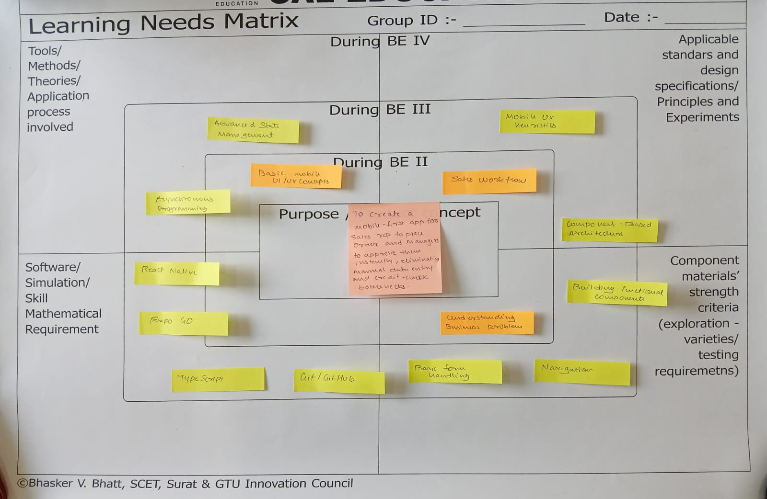
5.1Theory / Methods
- Advanced State Management (React Context API)
- Asynchronous programming (Promises, async/await)
- REST API Design
- Database schema (for Google Sheets)
- Authentication (JWT)
- Offline Synchronization patterns

5.2Applicable Standard Principles
Users: Field Sales Representatives, Distribution Managers, Warehouse Dispatch Staff, Shopkeepers (Customers).
- Mobile UX Heuristics
- Component-Based Architecture
- API security (CORS, auth)
- Data normalization
- Tally integration standards (CSV formats)

5.3Software Tools / Skills
- React Native (with Expo)
- TypeScript
- Git / GitHub
- Node.js (for future backend)
- Express.js (for future backend)

5.4Components/Strength
- Building functional components, navigation, and form handling
- Google Sheets API integration
- Full-stack project management
- Core Product Concept: A mobile-first app to eliminate manual data entry and credit-check bottlenecks.

Chapter 6
Prototype

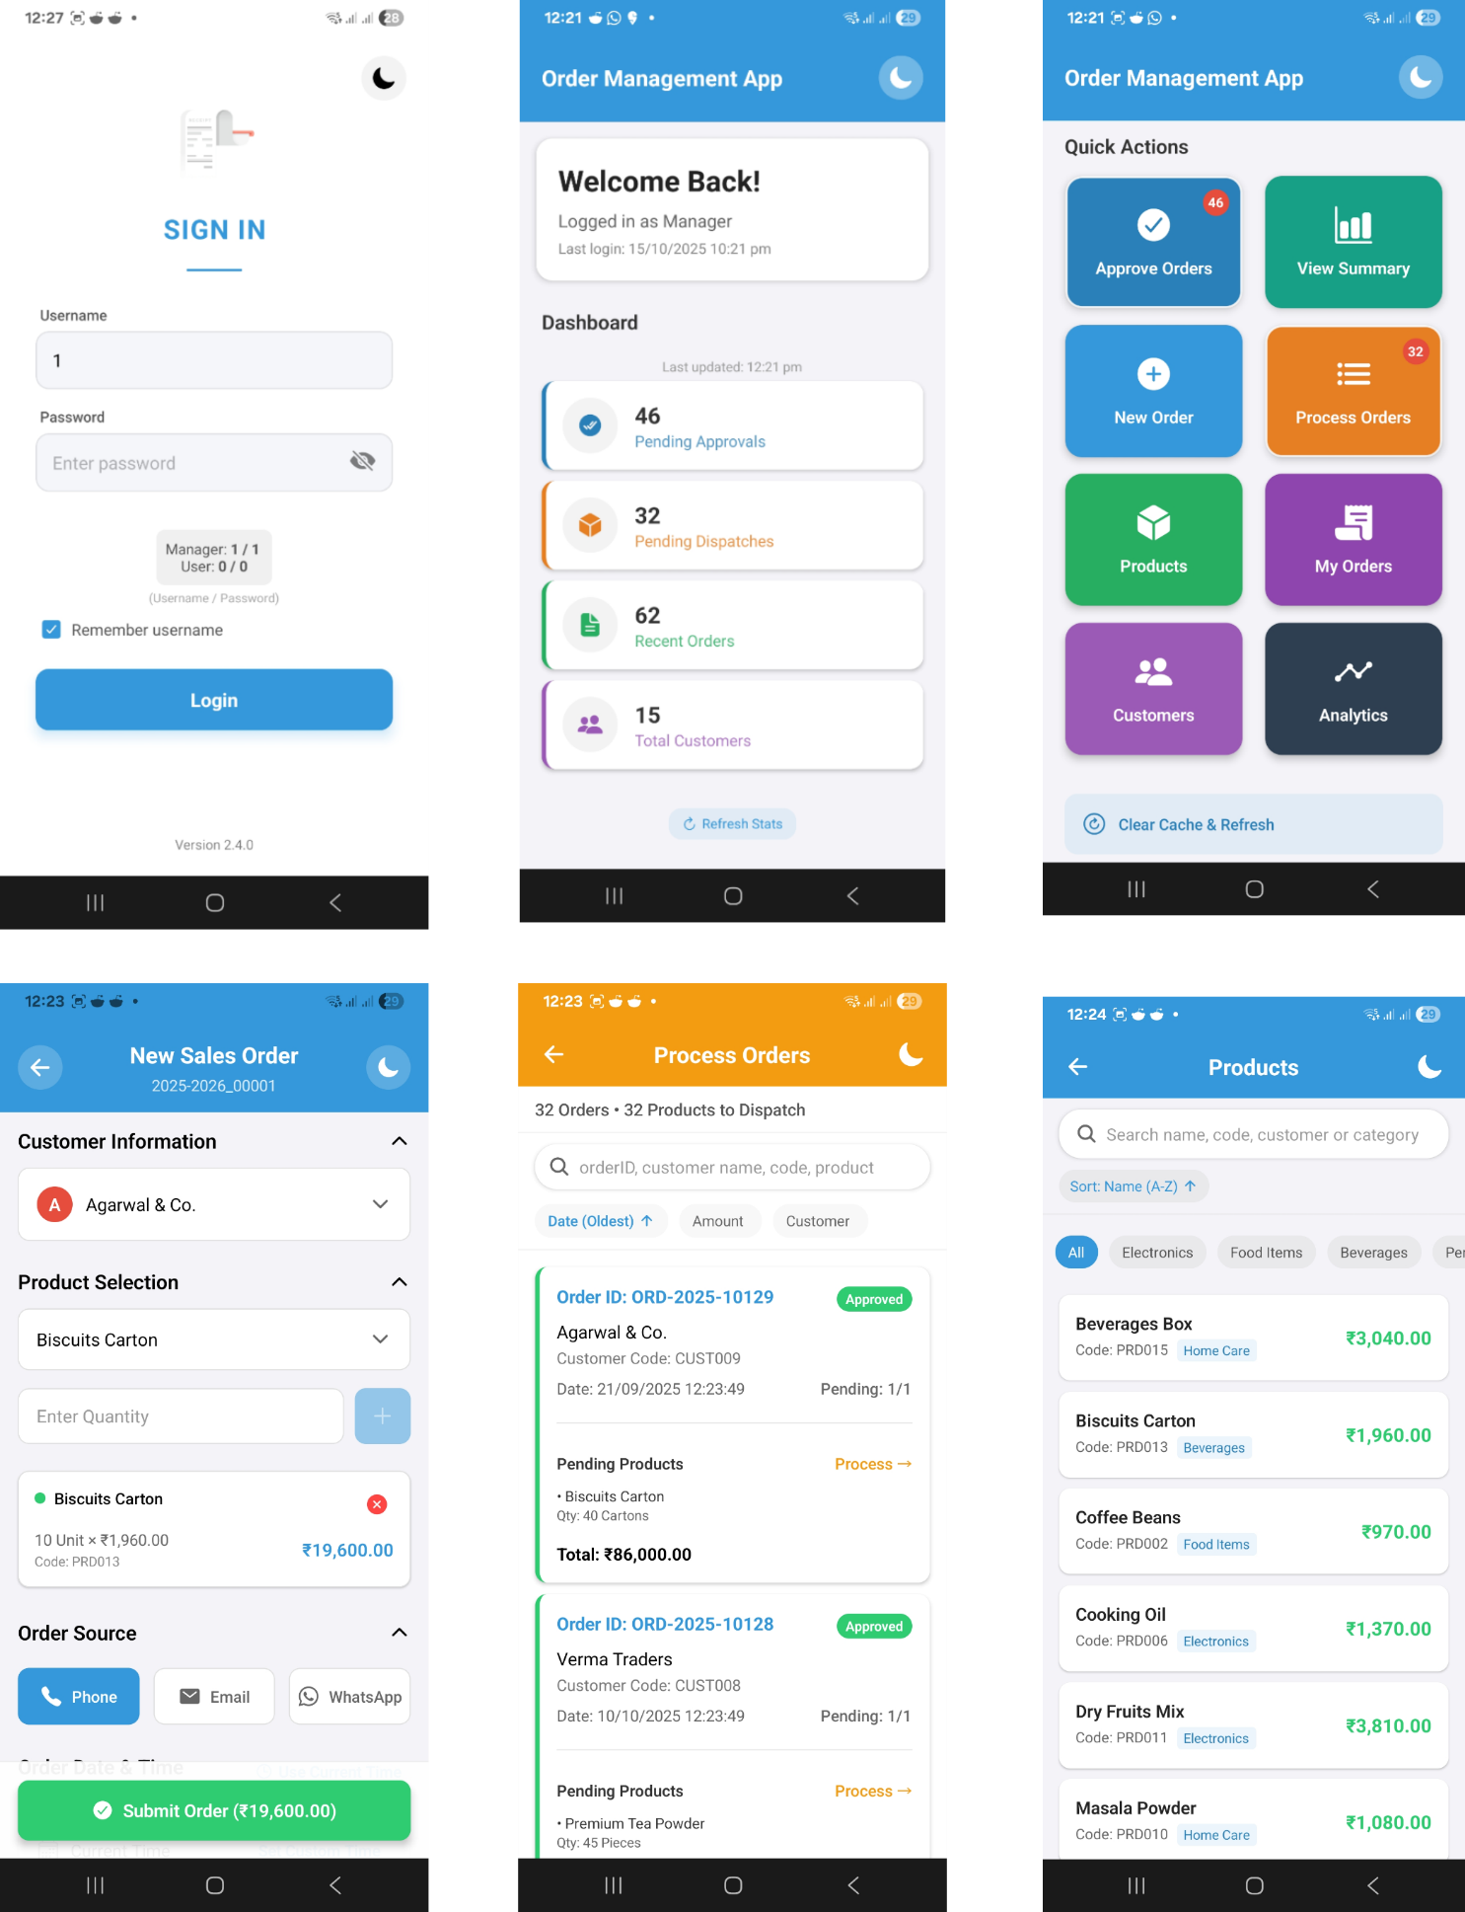
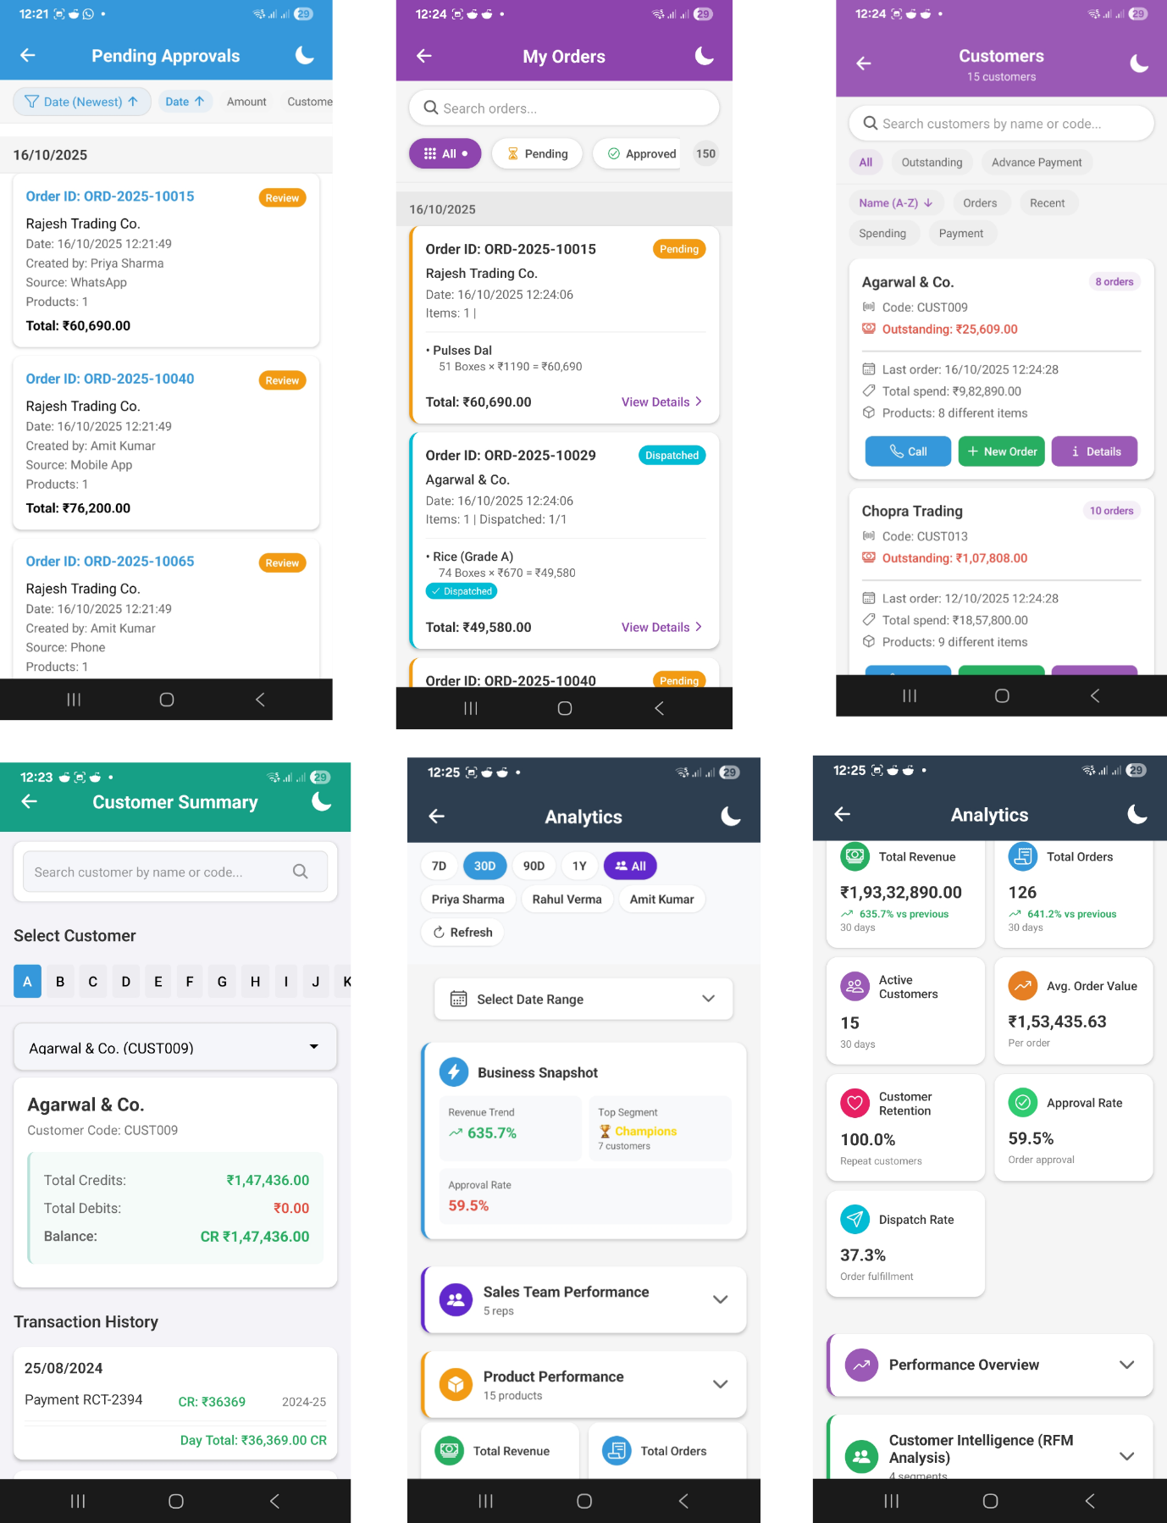

Chapter 7
Enhancements
7.1Future Enhancements
The current project successfully delivers a validated, high-fidelity frontend prototype. The planned enhancements for Semester 6 will focus on building the backend integration to make it production ready.
- Backend Integration: Develop a Node.js REST API server to manage data flow.
- Tally ERP Pipeline: Create a CSV export/import pipeline to sync data (Customers, Products, Orders) between Tally and the mobile app.
- Cloud Database: Use Google Sheets as an intermediate cloud database, manageable via the Node.js API, to store and sync data from Tally exports.
- Push Notifications: Implement push notifications to alert managers of new pending orders and sales reps of order approvals/rejections.
- Offline Synchronization: Enable offline capabilities, allowing sales reps to create orders without an internet connection, which will then sync automatically when connectivity is restored.

Chapter 8
Conclusion
8.1Conclusion
This project successfully demonstrates a comprehensive solution to the critical inefficiencies in traditional, Tally-based order management workflows. By applying design thinking principles, we identified and solved the core pain points of duplicate data entry and manual credit verification.
The final React Native prototype proves the feasibility and value of the proposed solution. It provides three distinct, role-based user experiences that are fast, intuitive, and mobile-first. The successful implementation of the deterministic mock data system allowed for full functionality testing and validation without a live backend.
The project meets its key success criteria: order creation in under 60 seconds, an approval workflow poised to take under 2 minutes (with the embedded ledger data), and the complete elimination of manual data entry for sales representatives. The app provides clear, immediate value by saving time, reducing errors, and providing real-time business intelligence. Future work will focus on integrating this validated frontend with a production backend to deliver a complete, market-ready solution.

